Common Code: dsplot.m

function [] = dsplot(f, name, haxis, vaxis)

stem(0:size(f) - 1, f);

if nargin > 1

title(name);

end

if nargin > 2

xlabel(haxis, 'FontSize', 18);

end

if nargin > 3

ylabel(vaxis, 'FontSize', 18);

end

set(gca, 'FontSize', 16);

grid on;

end

Problem 17

Code:

clear all;

N = 0:100;

a = [1, -1.15, 1.5, -.7, .25];

b = [.18, .1, .3, .1, .18];

figure;

% Part a

h = impz(b, a, N);

subplot(4, 1, 1);

dsplot(h, 'h[n]');

% Part b

x = ones(101, 1);

y = filter(b, a, x);

subplot(4, 1, 2);

dsplot(y, 'filter(b, a, u[n])');

% Part c

y = conv(h, x);

subplot(4, 1, 3);

dsplot(y, 'conv(h[n], u[n])');

% Part d

y = filter(h, 1, x);

subplot(4, 1, 4);

dsplot(y, 'filter(h[n], 1, u[n])');

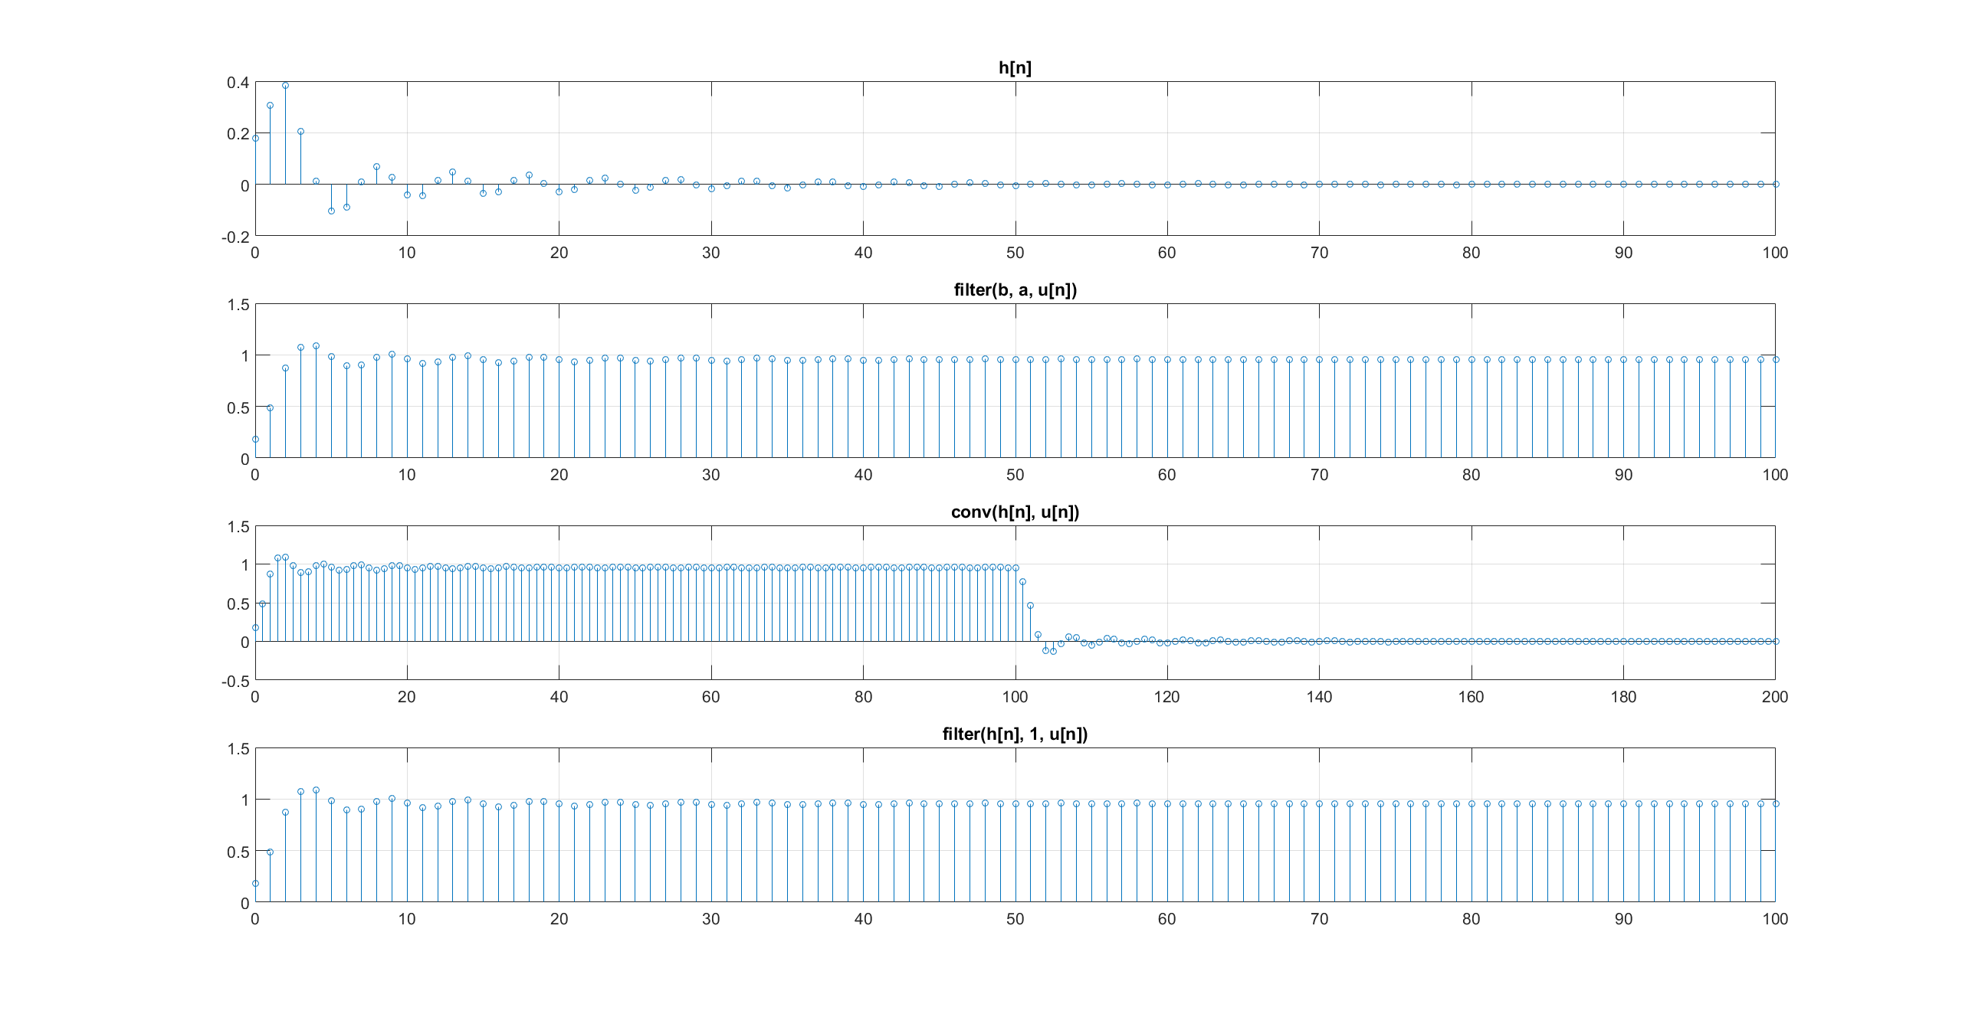

Problem 24

Code:

clear all;

x = load('djw6576.txt', '-ascii');

N = size(x, 1);

y1 = zeros(N, 1);

y2 = zeros(N, 1);

for n = 1:N

% y1 = sum_(0)_(50){x[n-k]}/51

for k = 0:50

if (n - k > 0 && n - k <= N)

y1(n) = y1(n) + x(n - k);

end

end

y1(n) = y1(n) / 51;

% y2 = sum_(-25)_(25){x[n-k]}/51

for k = -25:25

if (n - k > 0 && n - k <= N)

y2(n) = y2(n) + x(n - k);

end

end

y2(n) = y2(n) / 51;

end

figure;

subplot(3,1,1);

dsplot(x, 'x');

subplot(3,1,2);

dsplot(y1, 'y1');

subplot(3,1,3);

dsplot(y2, 'y2');

figure;

hold all;

plot(0:N-1, x, 'blue');

plot(0:N-1, y1, 'red');

plot(0:N-1, y2, 'green');

set(gca, 'FontSize', 16);

grid on;

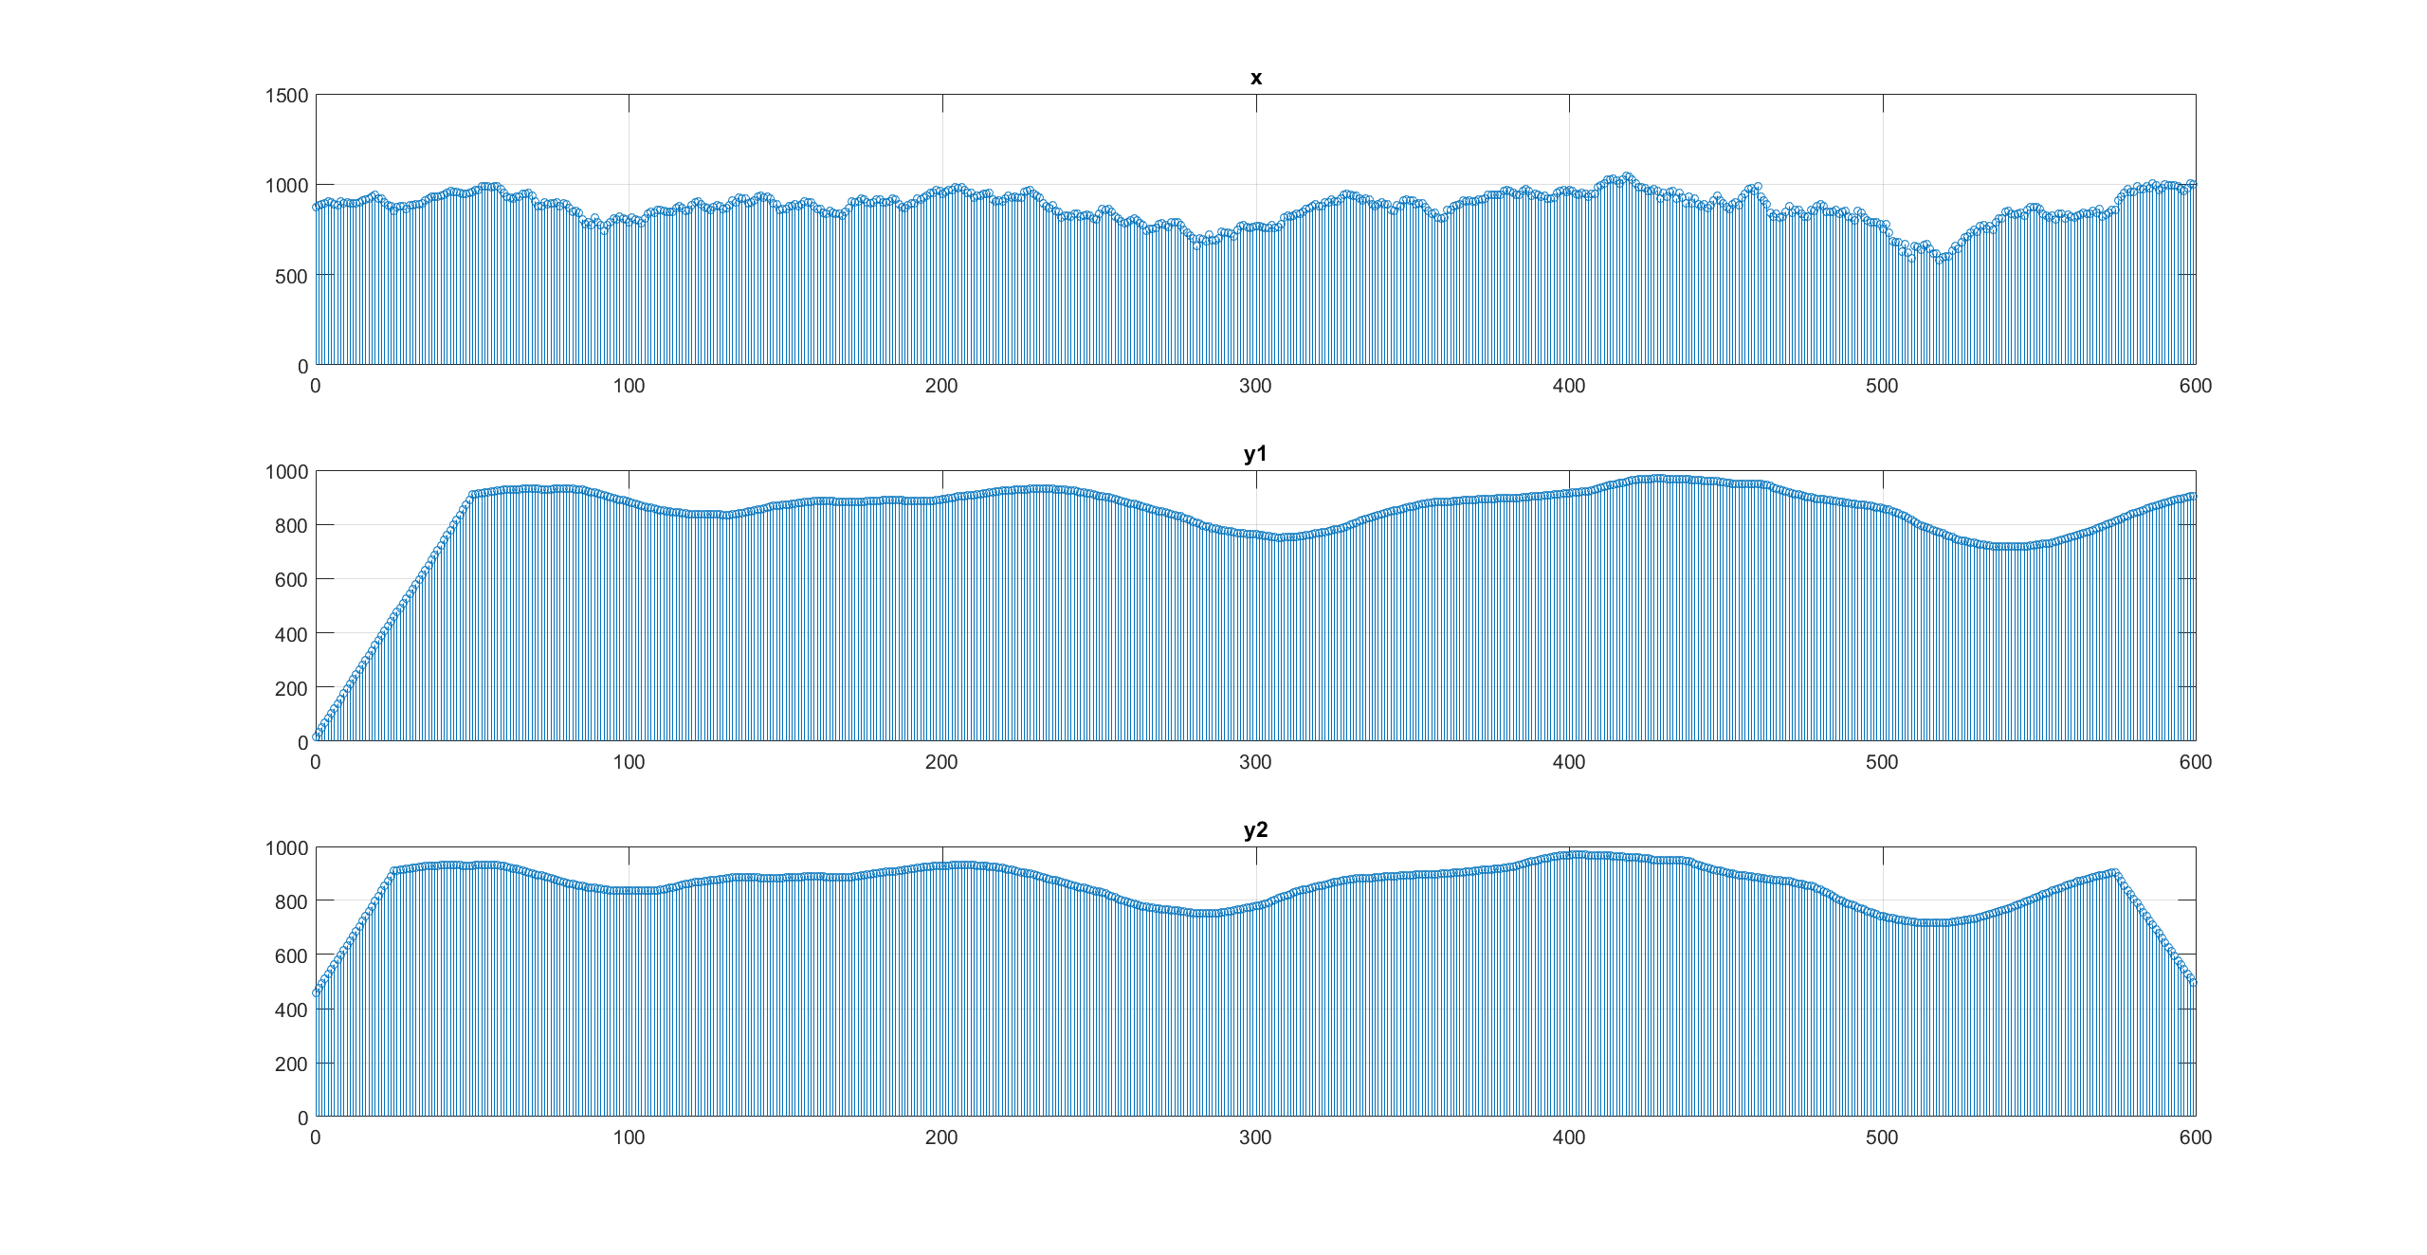

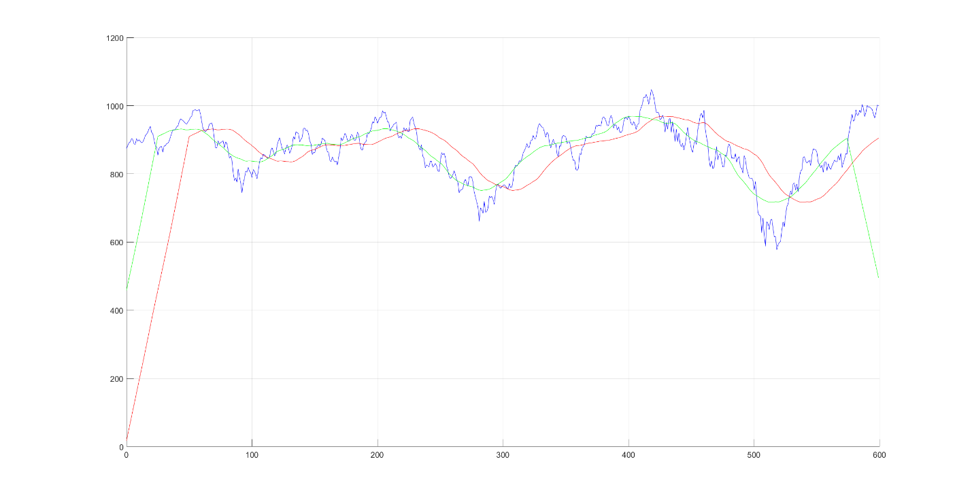

The book asked for a line plot with the 3 super-imposed (I know it’s not continuous)

Problem 25

Code:

clear all;

N = 10;

M = 5;

u = ones(1000, 1);

x = u(1:N);

h = 0:(M - 1) .* u(1:M);

y = conv(h, x);

figure;

dsplot(y, 'conv(h, x)');

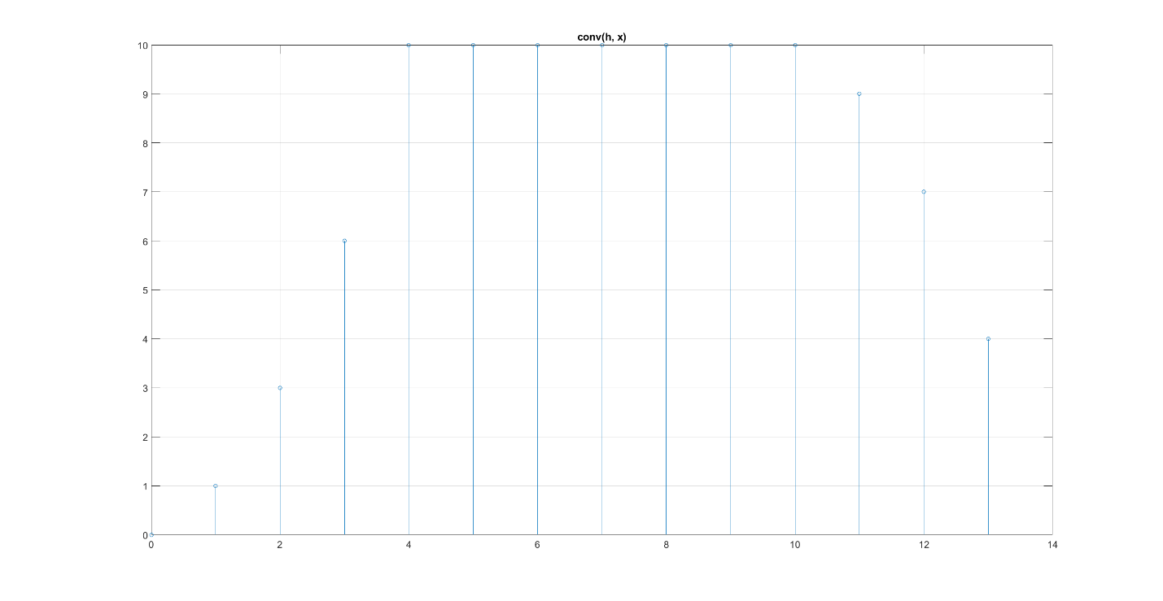

Problem 31

Code:

clear all;

a = [1, -1, -1];

b = 1;

N = 0:100;

% delta function

x = zeros(101, 1);

x(1) = 1;

% impulse response

h = filter(b, a, x);

dsplot(h, 'filter(b, a, delta(n))');

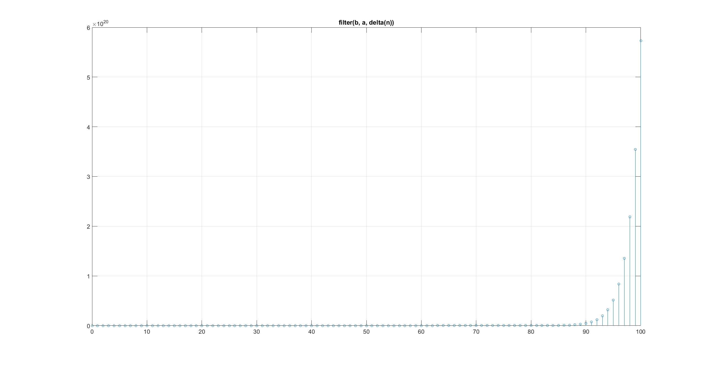

Problem 54

Code:

clear all;

% delta matrix

d = zeros(3, 3);

d(2,2) = 1;

h = [0, 1, 0;

1, -4, 1;

0, 1, 0];

H = d - h;

x = imread('lena.jpg');

y = conv2(double(x), h);

f = conv2(double(x), H);

figure;

subplot(1, 3, 1);

imagesc(x);

title('Original');

axis image;

colormap gray;

colorbar;

subplot(1, 3, 2);

imagesc(y);

title('Laplacian');

axis image;

colormap gray;

colorbar;

subplot(1, 3, 3);

imagesc(f);

title('Final');

axis image;

colormap gray;

colorbar;

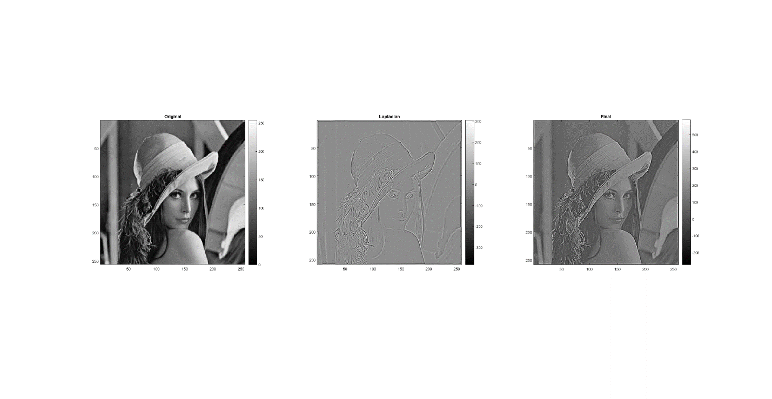

I not 100% certain what the images are supposed to look like; Matlab gave me weird warnings about using integers with conv2. I guess the image looks a little sharper after subtracting its Laplacian, but I don’t notice it too much compared to the dramatic change in color.